Questionnaire for Post-Amputation Pain (Q-PAP)

Post-amputation Pain
Pain following an amputation is categorized by its perceived location and divided into Residual Limb Pain (RLP) and Phantom Limb Pain (PLP). RLP refers to pain perceived in the remaining part of the limb that is not explained by prosthetic socket use or other identifiable causes (such as wounds, bursae, or cysts). PLP, on the other hand, refers to pain perceived in the missing part of the limb (see image below). It is important to distinguish PLP from non-painful phantom sensations, which are common and may include perceptions of limb position or movement without discomfort.

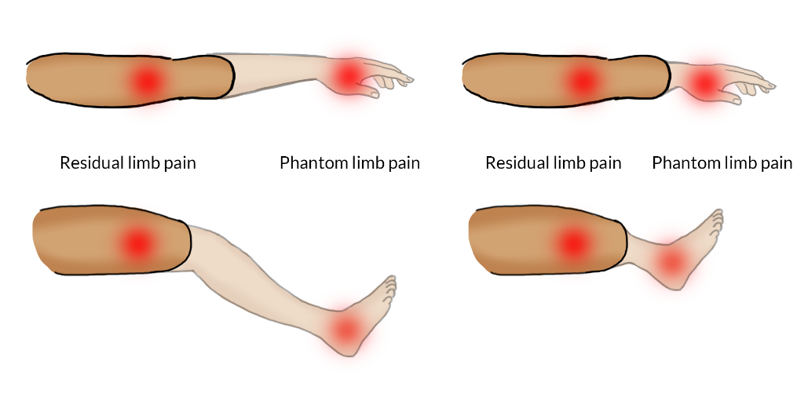
The position of the phantom limb can vary and is often perceived closer to the body than expected. In some cases, the phantom limb is perceived within the residual limb, and this can make it harder to distinguish between RLP and PLP. In such cases, it is advised to close the eyes and report the perceived location of pain by verbally naming the body part rather than pointing to the physical location.

Date:
Patient ID:
Limb:

1. Residual Limb Pain (RLP)

1.1 Current RLP intensity
Mark the number that best represents the current intensity of pain in your residual limb.
None | 0 | 1 | 2 | 3 | 4 | 5 | 6 | 7 | 8 | 9 | 10 | Worst  possible

1.2 Current RLP verbal description
Which word best describes your current pain in your residual limb?
- None
- Very mild
- Mild
- Moderate
- Severe
- Very severe/Extreme

1.3 Frequency of RLP
How often do you feel pain in your residual limb? (mark the most common one)
- Constantly
- Every day but not constantly
- Every week but not every day
- Every month but not every week
- Never

1.4 Interference of RLP in activities of daily living
Mark the number that best represents the interference of residual limb pain with your daily life.
No interference | 0 | 1 | 2 | 3 | 4 | 5 | 6 | 7 | 8 | 9 | 10 | Complete interference

1.5 Interference of RLP in sleep
Mark the number that best represents the interference of residual limb pain with your sleep.
No interference | 0 | 1 | 2 | 3 | 4 | 5 | 6 | 7 | 8 | 9 | 10 | Complete interference

2. Phantom Limb Pain (PLP)

2.1 Current PLP intensity
Mark the number that best represents the current intensity of pain in your phantom limb.
None | 0 | 1 | 2 | 3 | 4 | 5 | 6 | 7 | 8 | 9 | 10 | Worst  possible

2.2 Current PLP verbal description
Which word best describes your current pain in your phantom limb?
- None
- Very mild
- Mild
- Moderate
- Severe
- Very severe/Extreme

2.3 Frequency of PLP
How often do you feel pain in your phantom limb? (mark the most common one)
- Constantly
- Every day but not constantly
- Every week but not every day
- Every month but not every week
- Never

2.4 Interference of PLP in activities of daily living
Mark the number that best represents the interference of phantom limb pain with your daily life.
No interference | 0 | 1 | 2 | 3 | 4 | 5 | 6 | 7 | 8 | 9 | 10 | Complete interference

2.5 Interference of PLP in sleep
Mark the number that best represents the interference of phantom limb pain with your sleep.
No interference | 0 | 1 | 2 | 3 | 4 | 5 | 6 | 7 | 8 | 9 | 10 | Complete interference

2.6 PLP location
Mark the numbers in all the places where you feel pain in your phantom limb.
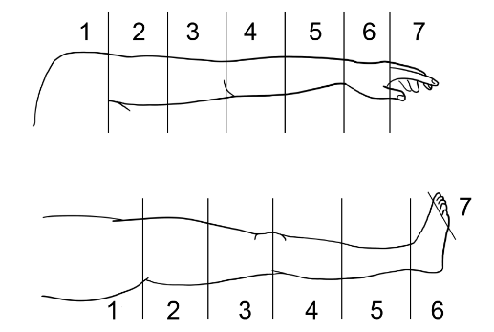

2.7 Phantom Limb Position
Is your phantom limb in a painful position? For example, bent backwards.
- No
- Yes

2.8 Phantom Limb Movement
Are you able to move your phantom limb?
- No, it is “frozen” in place
- Yes, but limited in both speed AND range of motion
- Yes, but limited in only speed OR range of motion
- Yes, movement is completely unrestricted in both speed and range of motion

2.9 Phantom Limb Sensation
Do you feel non-painful sensations in your missing limb?
- No, I do not feel a phantom limb at all
- Yes, faintly and incomplete (I barely feel the missing limb and only a part of it)
- Yes, faintly and complete (I barely feel the missing limb but all of it)
- Yes, vividly and incomplete (I vividly feel the missing limb but only a part of it)
- Yes, vividly and complete (I vividly feel the entirety of the missing limb)

3. Situational Changes

3.1 Prosthetics (skip if this is the first visit/session)
Answer only if there have been changes to your prosthesis since your last visit/session.
- Changes of prosthesis type or means of attachment (socket):

- Changes of hours per day using the prosthesis:

- Changes of activities using the prosthesis:

- Any other changes regarding your prosthesis:

3.2 Medication (skip if this is the first visit/session)
Answer only if there have been changes to your medication since your last visit/session.
- Changes of dosage of ongoing medication (medication name, old dosage, new dosage):

- New medication (medication name, dosage):

- Stop medication (medication name, dosage):

- Any other changes regarding medications:

3.3 Additional comments
Please describe any changes or situations that you think have influenced your pain, for example, additional treatments, other medical conditions, situational stress (e.g., sleep reduction, anger, sadness), etc.

International Association for the Study of Pain (IASP), Schug et al., Pain, 2019.

